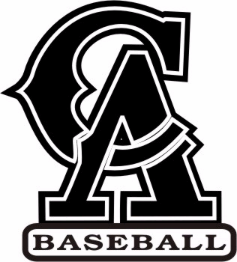

CENTRAL ARIZONA COLLEGE
SUMMER PROSPECT CAMP

Location: Central Arizona College Baseball Field
Tuesday June 4th, 2019
Starts: 9:00 am/Ends: 12:00 pm - Registration starts at 8:30
Camp Cost: $50
Ages: 14-18 (High School)

Central Arizona Baseball presents the 2019 Summer Prospect Camp. This camp will evaluate high school players in a half-day high-paced setting. Coaches will evaluate athlete’s defense, hitting, base running and pitching. The Summer Prospect Camp will give players the opportunity to interact and be seen by one of the top Junior college programs in the country.

Central Arizona College has won the Region 1 Championship 11 of the past 18 years while amassing 866 wins during this time. 165 players have been selected directly from CAC in the MLB draft and 18 have played in the Major Leagues including current MLB All-Star Ian Kinsler of the San Diego Padres.

Players should bring their glove, bat, batting gloves, helmets, baseball pants, cleats, turf shoes, and a snack, catchers should bring their own catchers gear and please label all personal items. Water provided.

For registration please fill out the liability waiver along with the bottom of this form and mail to:
CAC BASEBALL c/o Joe Perez
8470 North Overfield Road
Coolidge, AZ 85128

Include:
Name of player_____________________________Email______________________________________
Graduation Year_________Phone_______________________HT_________WT_______B/T_________
Position(s) played_________________________High School___________________________________
Summer/Fall Team__________________________________

Check payable to CAC Baseball/Joe Perez
Sorry NO REFUNDS
For questions contact Joe Perez at joseph.perez3@centralaz.edu or call 602-561-2995.

